**Phenomenon analysis and experiment**

**Experiment 1, observe the crosstalk signal**

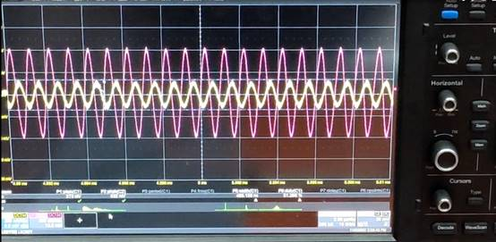

Peak to peak value of crosstalk signal

Peak value of interference line voltage

Analysis: crosstalk signal appears on the receiving line.

1.Crosstalk is the noise caused by coupling between two signal lines, liver protection and mutual capacitance between signal lines.Capacitive coupling leads to coupling current, while inductive coupling leads to coupling voltage.The parameters of PCB layer, the distance between signal lines, the electrical characteristics of driver and receiver, and the way of line termination have certain effects on crosstalk.

       2Influencing factors: frequency of coupling and interference signal, cable spacing, distance to ground, cable shielding, etc

**Experiment 2, observe the crosstalk signal changes with the distance between transmission lines**

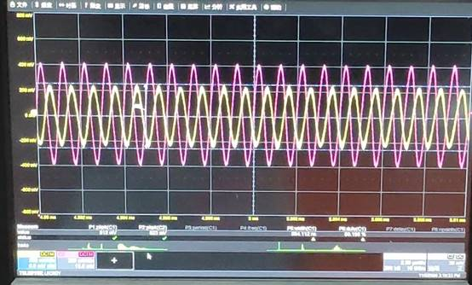

Peak to peak value of crosstalk signal

Peak value of interference line voltage

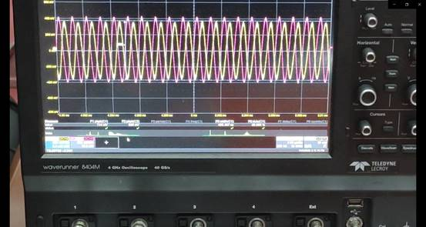

Peak to peak value of crosstalk signal

Peak value of interference line voltage

The experimental phenomena were as follows

When the distance between two lines decreases, the amplitude of crosstalk signal increases gradually

Cause analysis:

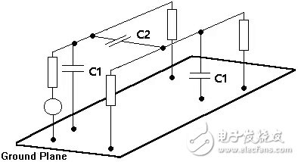

A capacitor is formed when two regular parallel plate conductors are filled with dielectric.In the case of PCB, capacitors will also be formed between the two traces and the reference plane. In the figure, C1 represents the capacitance formed between the trace and the reference plane, and C2 represents the capacitance formed between the two traces.From the point of view of capacitance, when a line voltage changes, it is equivalent to the voltage change at both ends of capacitor C2. When capacitor C2 is charged, there must be current on the adjacent conductor (the other end of capacitor), and the crosstalk will occur.The capacitance between the lines is closely related to the distance between the lines. When the spacing is reduced, the coupling capacitance increases rapidly and the coupling effect strengthens sharply.

**Experiment 3, observe the crosstalk signal changes with the transmission signal frequency**

When the signal of signal generator is reduced from 100MHz to 600kHz

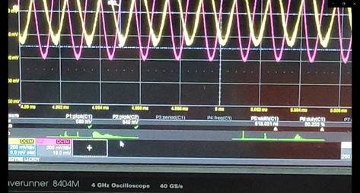

Peak to peak value of crosstalk signal

Peak value of interference line voltage

It can be seen that the peak value of crosstalk signal decreases from 744mv to 589mv compared with 1MHz

When the frequency continues to decrease to 300kHz

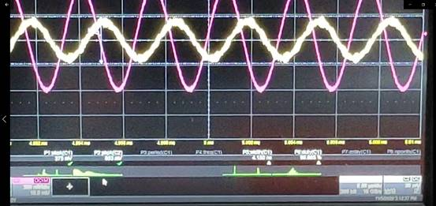

Peak to peak value of crosstalk signal

Peak value of interference line voltage

Cause analysis: as the frequency increases, the capacitance reactance of coupling capacitance increases, which weakens the coupling effect and reduces the peak value of crosstalk signal

**In Experiment 4, the effect of ground plane on crosstalk was observed**

When the third transmission line is not grounded (1MHz)

Waveforms of crosstalk signal and attack line signal

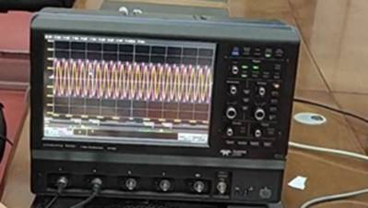

When the third transmission line is grounded (1MHz)

Waveforms of crosstalk signal and attack line signal

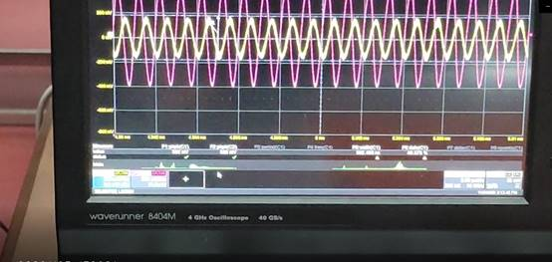

Peak to peak value of crosstalk signal

Peak value of interference line voltage

Cause analysis: when the transmission line is grounded, the ground plane has shielding effect, so the peak value of crosstalk signal decreases